Gateway

🌐 What is a Gateway in Networking?
# Source: AI Source: Provided by: [Data Path: Persons Table -> ID Column: 1, Name_En Column: Motasem Essam] -> From: [ChatGPT] on [12/18/2025]
A Gateway is a networking device (or software service) that connects two different networks that use different communication protocols. It acts as a translator or bridge between networks, allowing data to flow between them — even if they speak different "languages."
✅ Think of a gateway as the entrance and exit point between your network and the outside world (like the internet or another internal network).

🔄 What Does a Gateway Do?
# Source: AI Source: Provided by: [Data Path: Persons Table -> ID Column: 1, Name_En Column: Motasem Essam] -> From: [ChatGPT] on [12/18/2025]
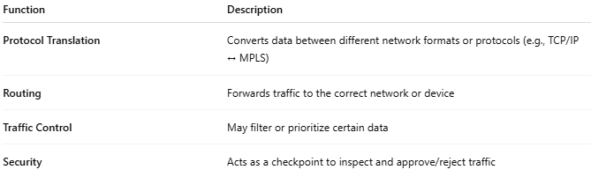

Function | Description
Protocol Translation | Converts data between different network formats or protocols (e.g., TCP/IP ↔ MPLS)
Routing | Forwards traffic to the correct network or device
Traffic Control | May filter or prioritize certain data
Security | Acts as a checkpoint to inspect and approve/reject traffic

🏠 Common Example (Home Network)
# Source: AI Source: Provided by: [Data Path: Persons Table -> ID Column: 1, Name_En Column: Motasem Essam] -> From: [ChatGPT] on [12/18/2025]
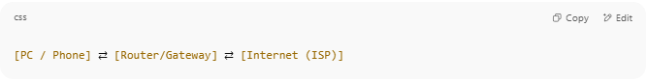
[PC / Phone] ⇄ [Router/Gateway] ⇄ [Internet (ISP)]

- Your home router acts as a default gateway, allowing devices on your LAN to access the internet.

🧠 Types of Gateways
# Source: AI Source: Provided by: [Data Path: Persons Table -> ID Column: 1, Name_En Column: Motasem Essam] -> From: [ChatGPT] on [12/18/2025]
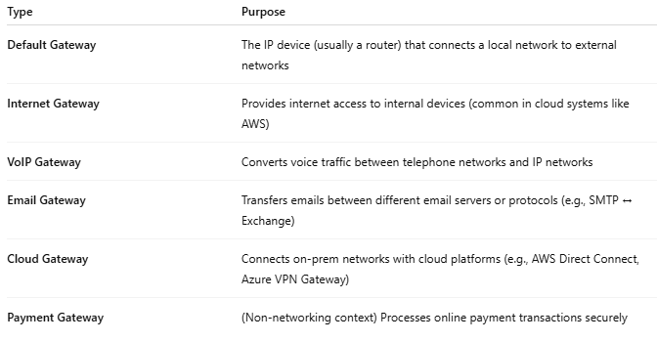
Type | Purpose
Default Gateway | The IP device (usually a router) that connects a local network to external networks
Internet Gateway | Provides internet access to internal devices (common in cloud systems like AWS)
VoIP Gateway | Converts voice traffic between telephone networks and IP networks
Email Gateway | Transfers emails between different email servers or protocols (e.g., SMTP ↔ Exchange)
Cloud Gateway | Connects on-prem networks with cloud platforms (e.g., AWS Direct Connect, Azure VPN Gateway)
Payment Gateway | (Non-networking context) Processes online payment transactions securely

🔧 Gateway vs Router vs Firewall
# Source: AI Source: Provided by: [Data Path: Persons Table -> ID Column: 1, Name_En Column: Motasem Essam] -> From: [ChatGPT] on [12/18/2025]
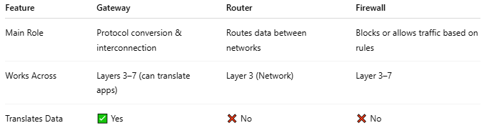

Feature | Gateway | Router | Firewall
Main Role | Protocol conversion & interconnection | Routes data between networks | Blocks or allows traffic based on rules
Works Across | Layers 3–7 (can translate apps) | Layer 3 (Network) | Layer 3–7
Translates Data | ✅ Yes | ❌ No | ❌ No

✅ Pros
# Source: AI Source: Provided by: [Data Path: Persons Table -> ID Column: 1, Name_En Column: Motasem Essam] -> From: [ChatGPT] on [12/18/2025]
- ✅ Enables communication between incompatible networks
- ✅ Essential for internet access
- ✅ Flexible (can be hardware or software)
- ✅ Supports advanced routing and security

❌ Cons
# Source: AI Source: Provided by: [Data Path: Persons Table -> ID Column: 1, Name_En Column: Motasem Essam] -> From: [ChatGPT] on [12/18/2025]
- ❌ Single point of failure (if gateway goes down, no external access)
- ❌ May introduce latency due to data processing
- ❌ Can be complex to configure in large enterprise networks

📌 Summary
# Source: AI Source: Provided by: [Data Path: Persons Table -> ID Column: 1, Name_En Column: Motasem Essam] -> From: [ChatGPT] on [12/18/2025]
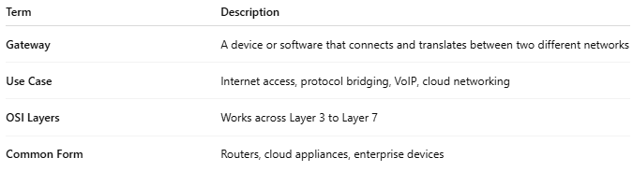

Term | Description
Gateway | A device or software that connects and translates between two different networks
Use Case | Internet access, protocol bridging, VoIP, cloud networking
OSI Layers | Works across Layer 3 to Layer 7
Common Form | Routers, cloud appliances, enterprise devices

